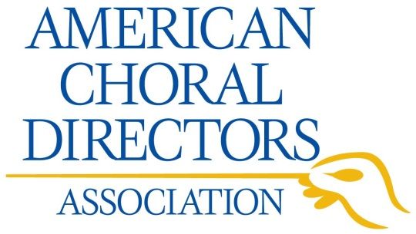
Standing Committee Grant Information & Application
This grant provides funding to foster and promote creative and innovative projects that further the mission of one or more of the American Choral Directors Association standing committees.

Funding Priorities
- Aligns with committee goals
- Focused on choral work and/or singing
- Innovative and creative
- Sustainable
- Collaborative (e.g., with other funder involvement and/or implementation partners)
- Replicable or adaptable to other settings (e.g., regions, states)

Application Requirements
Rolling deadline. Submit when completed and your application will be put on the next EC agenda for discussion.

Applications should be submitted by committee chairs, typed, and fit within the allotted space on the application form. Please email all application parts in one email to sflansburg@acda.org, or submit 1 copy to (keep a copy for your records):
ACDA Standing Committee Grant Application
545 Couch Dr
Oklahoma City, OK 73102-2207

Projects will be funded for no more than one year and cannot be used for individual travel or as a donation to support any organization outside of ACDA. Unused funds cannot be carried over to another year. Committee chairs are encouraged to consider funding as seed money, and apply for grants up to $5,000.

Upon completion of funded projects, a final report must be submitted no later than 45 days from the time the project ends. Awardees agree that ACDA may share information about the project with members and others, and to make replicable or adaptable resources available to regions and states.

Questions?
Contact Sundra Flansburg, ACDA Director of Membership & Communications, sflansburg@acda.org.

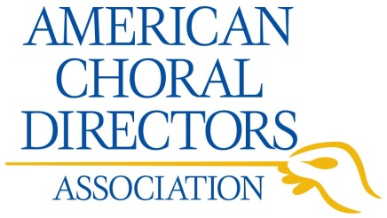

Cover Page

Please type or prepare the application online and then print it. No handwritten applications will be considered.

Applicant

Standing committee name:

Standing committee chair:

Email address:

Preferred daytime telephone number:

Date application submitted:

Summary of Proposed Project

Title of project:

Dates project starts and ends:

Primary goal of project:

Number of people directly impacted:

Number of people indirectly impacted:

Funding requested: Total cost of project:

Project Summary (200 word maximum):

Signature of applicant & date:

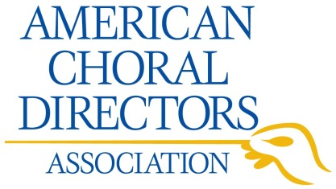
Proposed Project

Please type or prepare the application online and then print it. No handwritten applications will be considered. If you have any questions or need assistance with the application, contact Sundra Flansburg at sflansburg@acda.org.

- Project Description (please use no more than one page to do this)
Include information on how the project addresses any of the funding priorities (page 1), ACDA mission, and standing committee goals. Also note sustainability plans and potential direct and indirect impacts of the project.

- Project Timeline
List the steps for project implementation, as well as the planned dates for them.

- Project Budget ($500 - $5,000)
Please provide a line item budget, including materials & supplies, consultant costs, etc.; these amounts should be researched and reflect true costs. Please note that in most cases the standing committee grants will not cover salaries, nor reimburse for dollars already spent. If you are requesting only partial funding from ACDA, indicate information on other funding sources and how the costs will be allocated between funders.

- Budget Justification
Please provide any information needed to justify the expenses involved in this project.

